Pariyojna

Sardar narm svabhav k hote hai

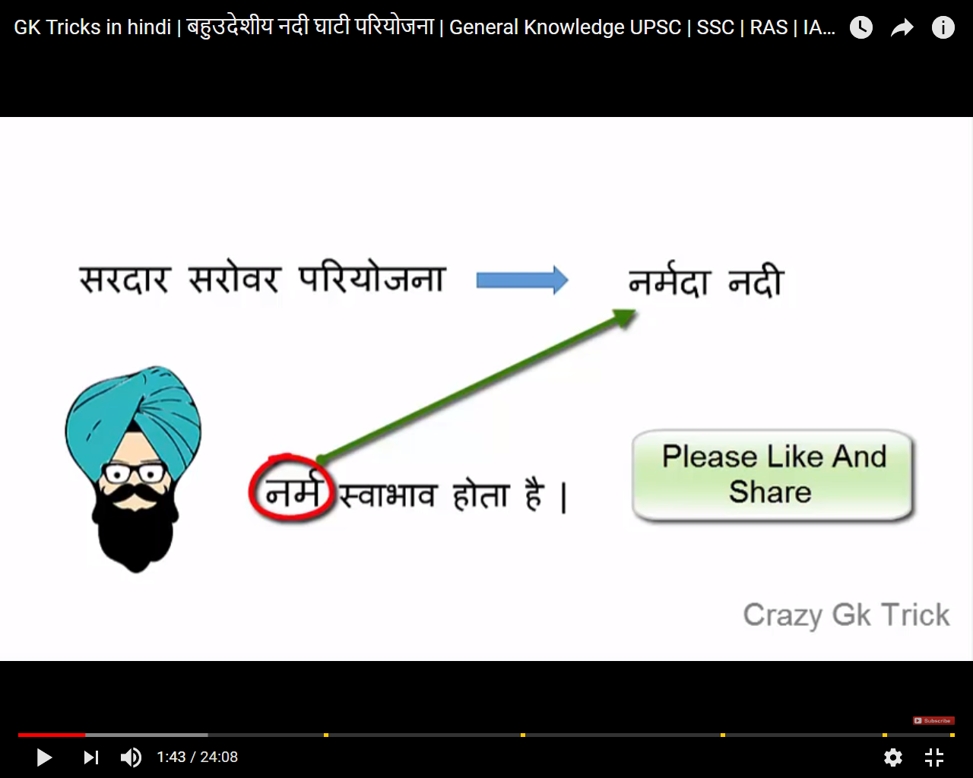

Amerkanthak madyapradesh

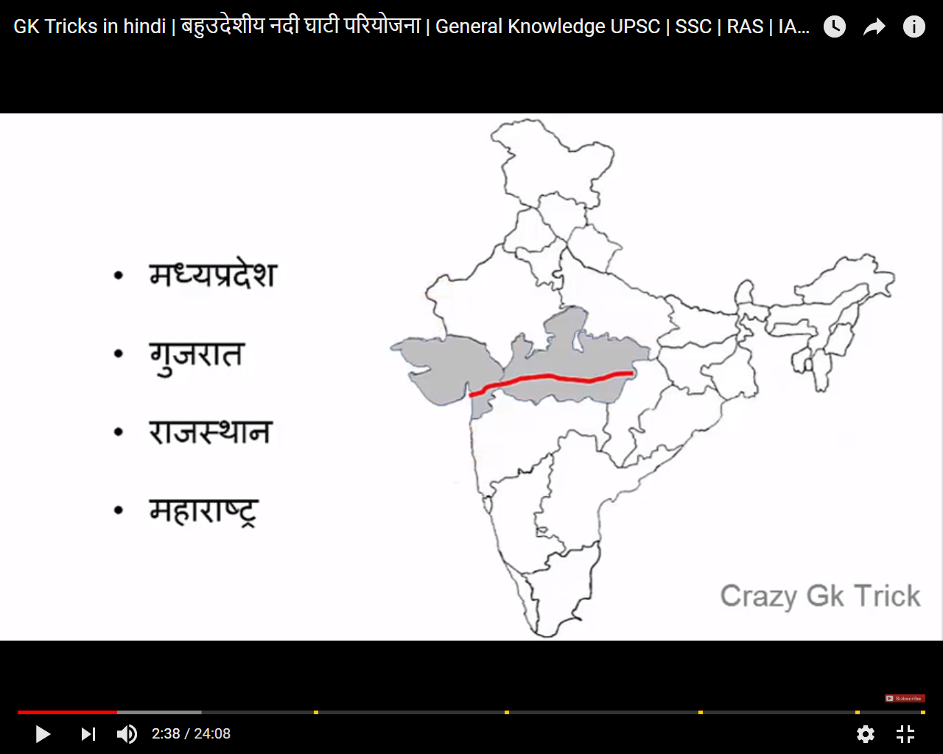

Mayur -Mor -ye mor jb murli sunege to pacchim bangal me aa jate hai.

Murli-Murli nadi

Mor udd k aye hoge-Farakka-Ganga river

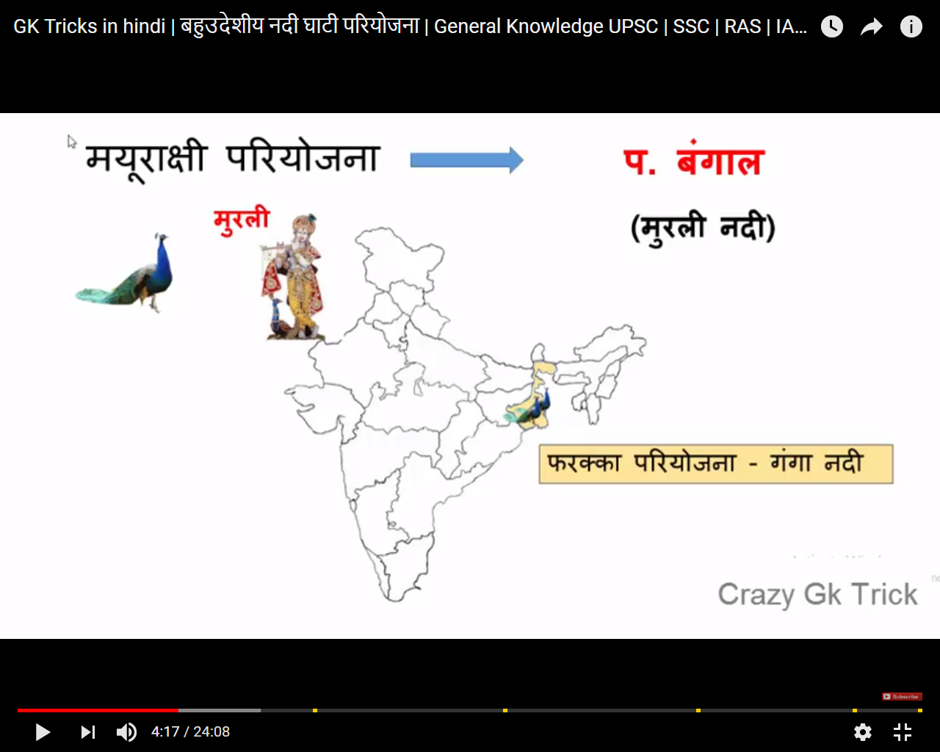

MAHARASTRA

Maharastra me actor hote hai.Waha per actor ka audition ho rha tha.ek kabaddi wali ne daav khel aur gir gaya. Aur bahar ho gay ,Log bole Koen a fir se.

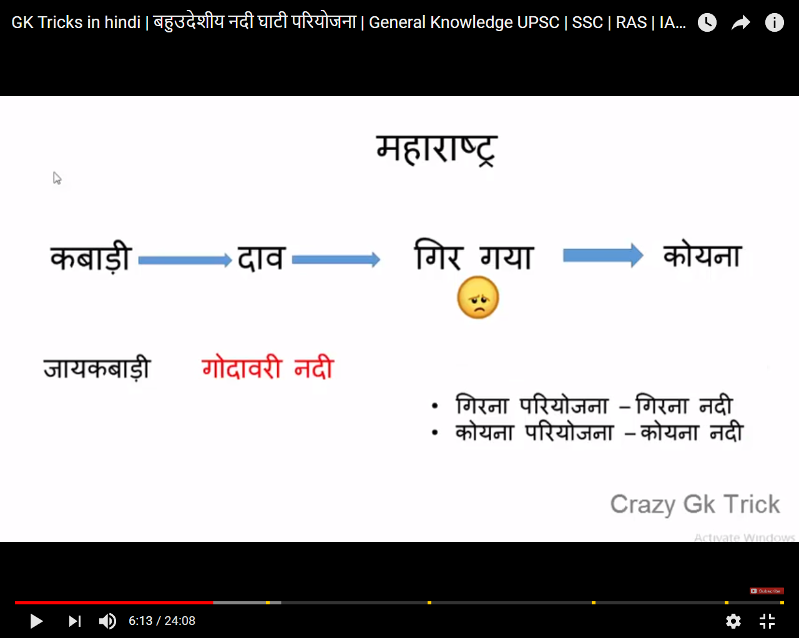

Jamu Kashmir

River-Chenab River

Bharat matta ka lal-Salal water pariyojna

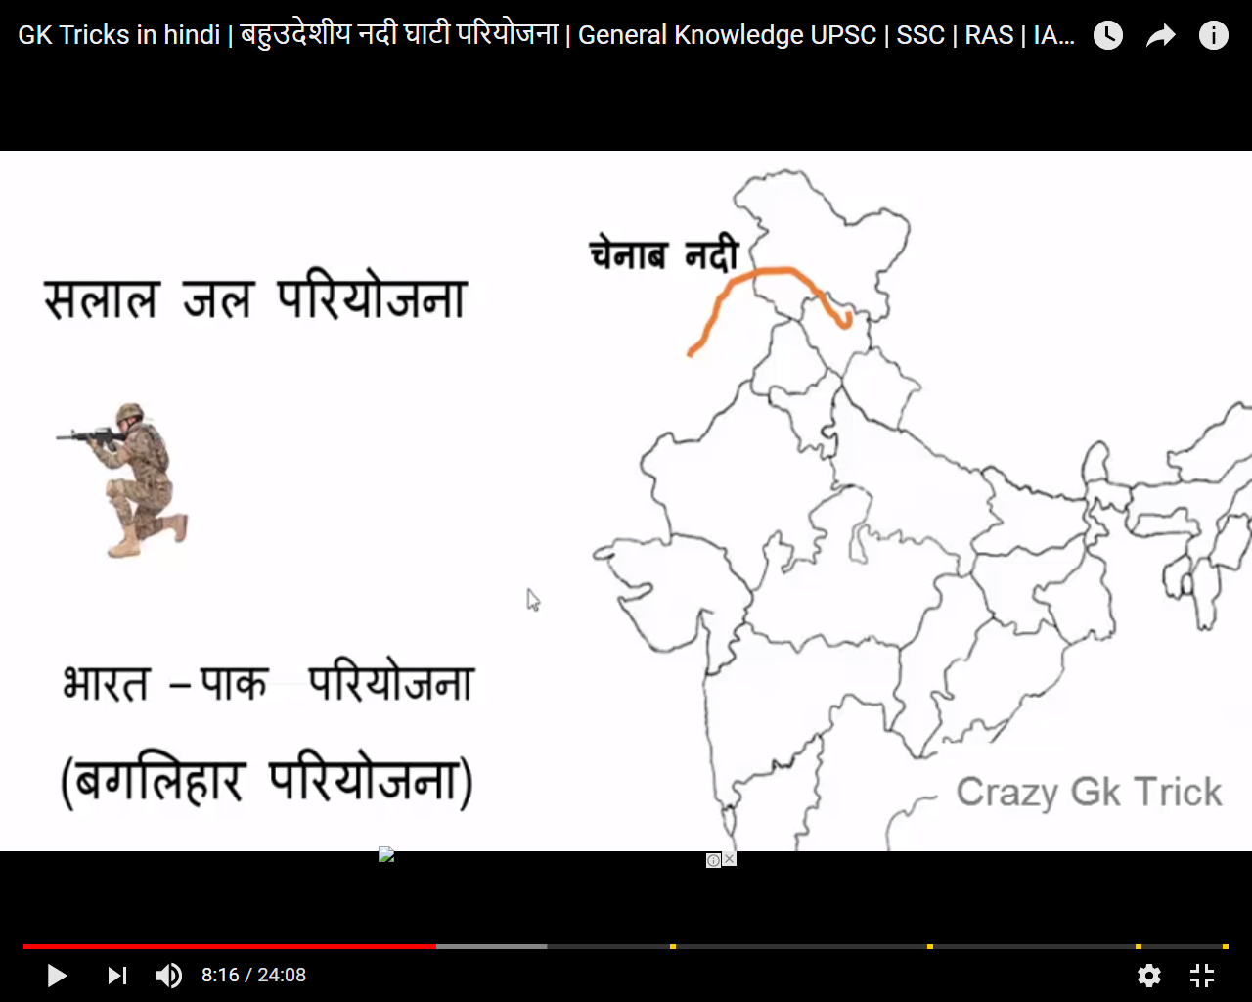

Rihand Dam pariyojna-uttar Pradesh and bihar

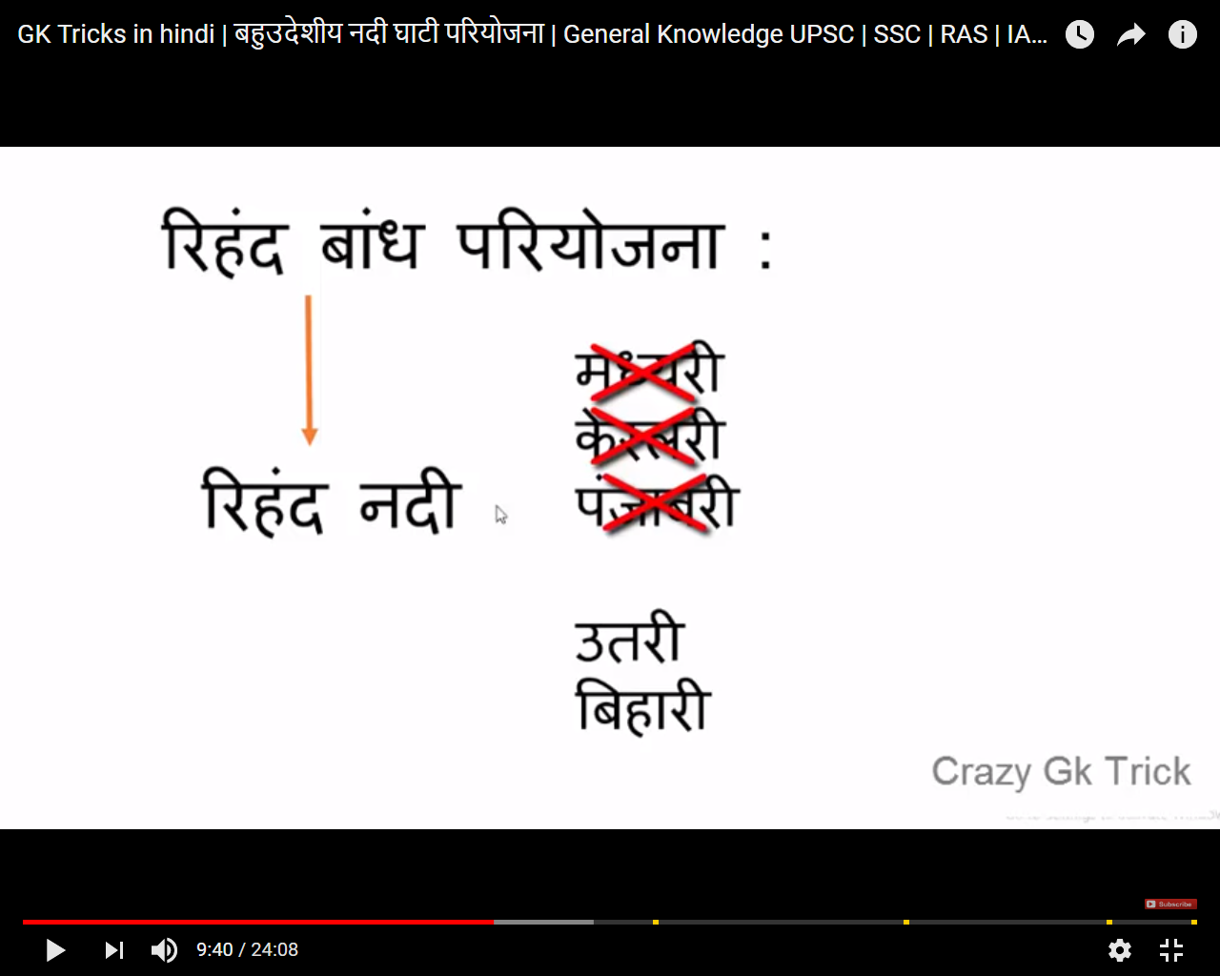

[Bhakra nangal dam](https://www.google.co.in/search?q=bhakra+nangal+dam&rlz=1C1RUCY_enIN718IN718&tbm=isch&tbo=u&source=univ&sa=X&ved=2ahUKEwjW6tLo5fHcAhVBMt4KHdnPDTsQsAR6BAgBEAE)-Naa GAL(gaalne laga hai)-Luj ho gaya

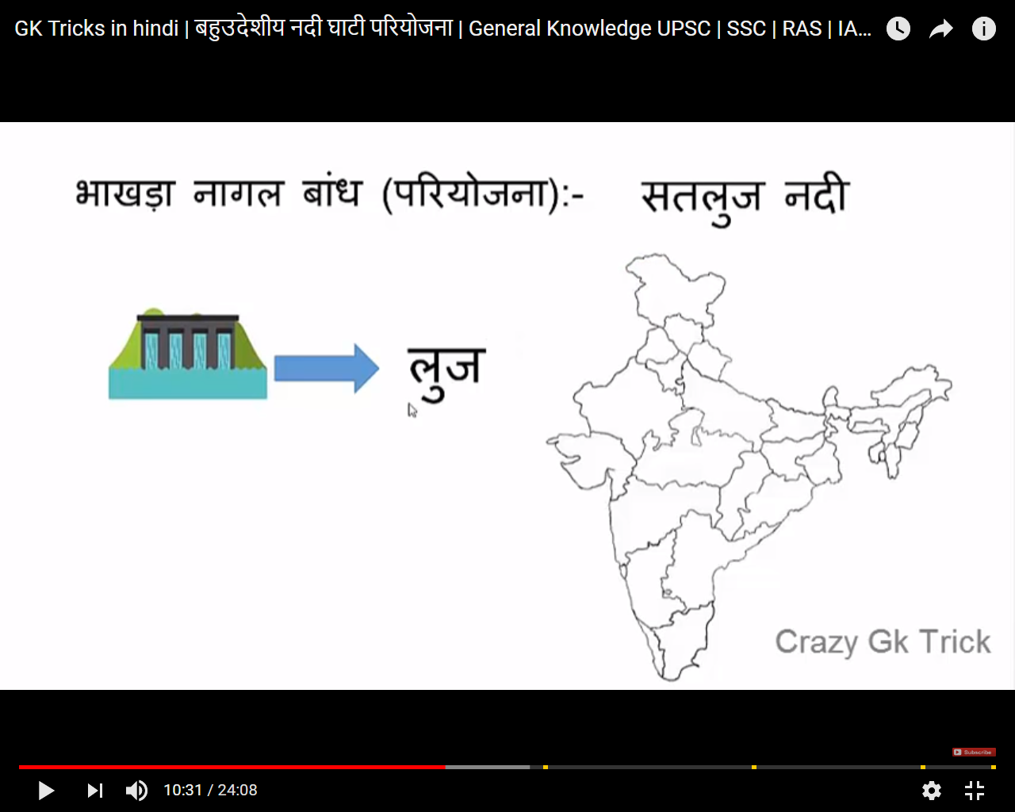

China -India-Pakistan

Himachal-Bakra nagal -Pujab-Hariyan-Rajsthan

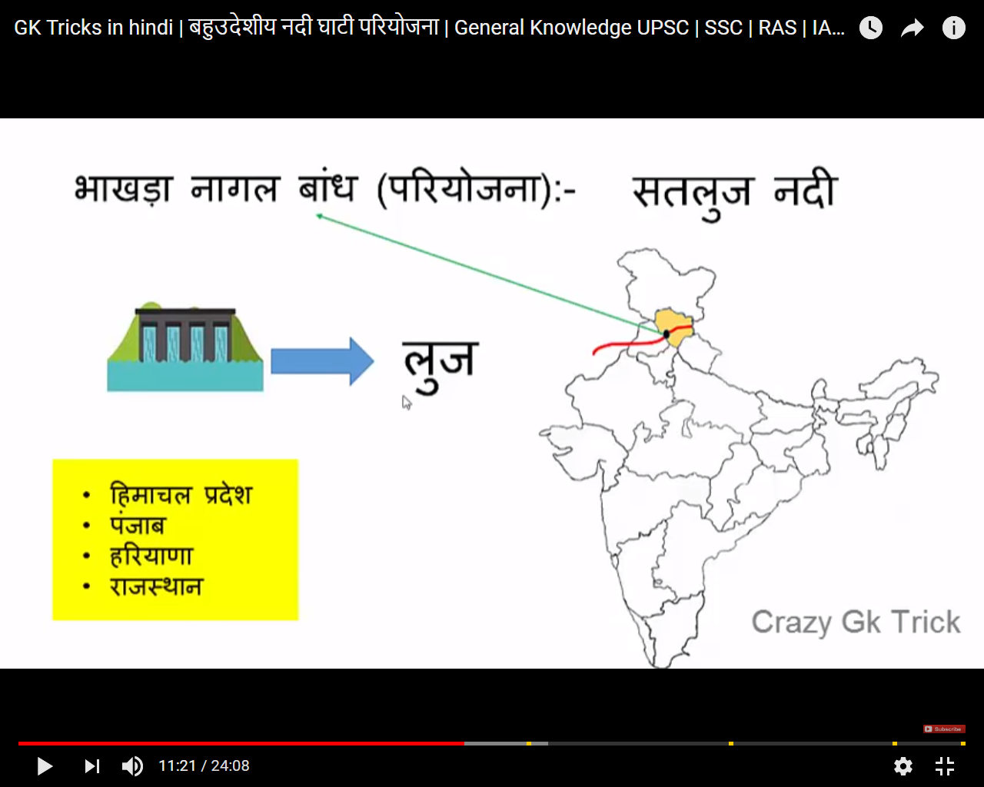

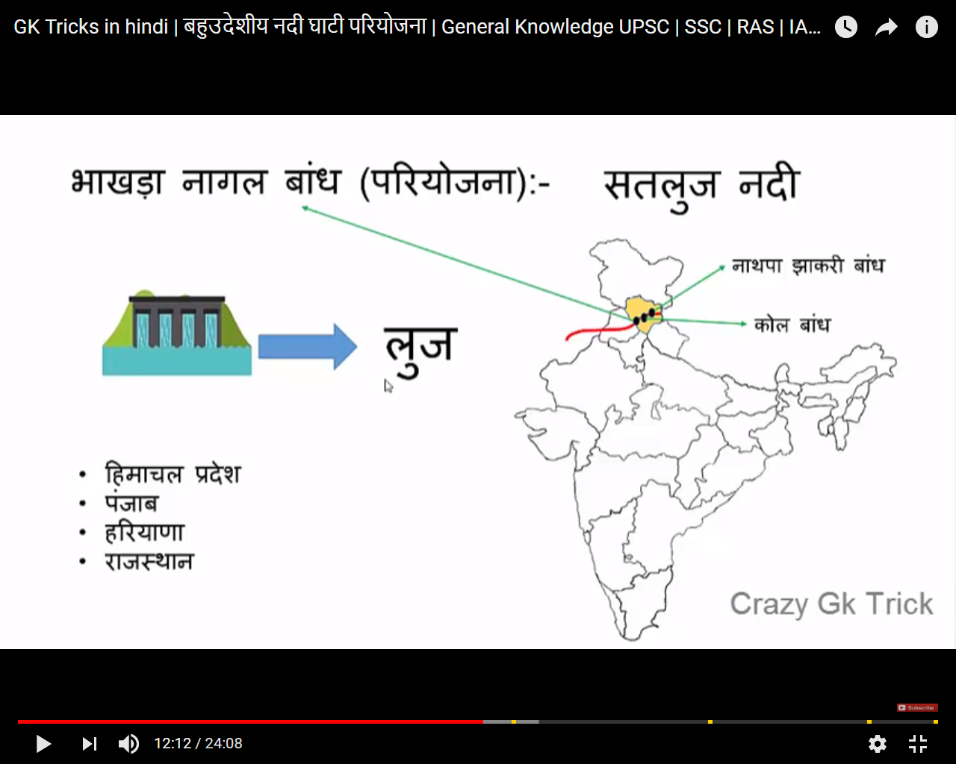

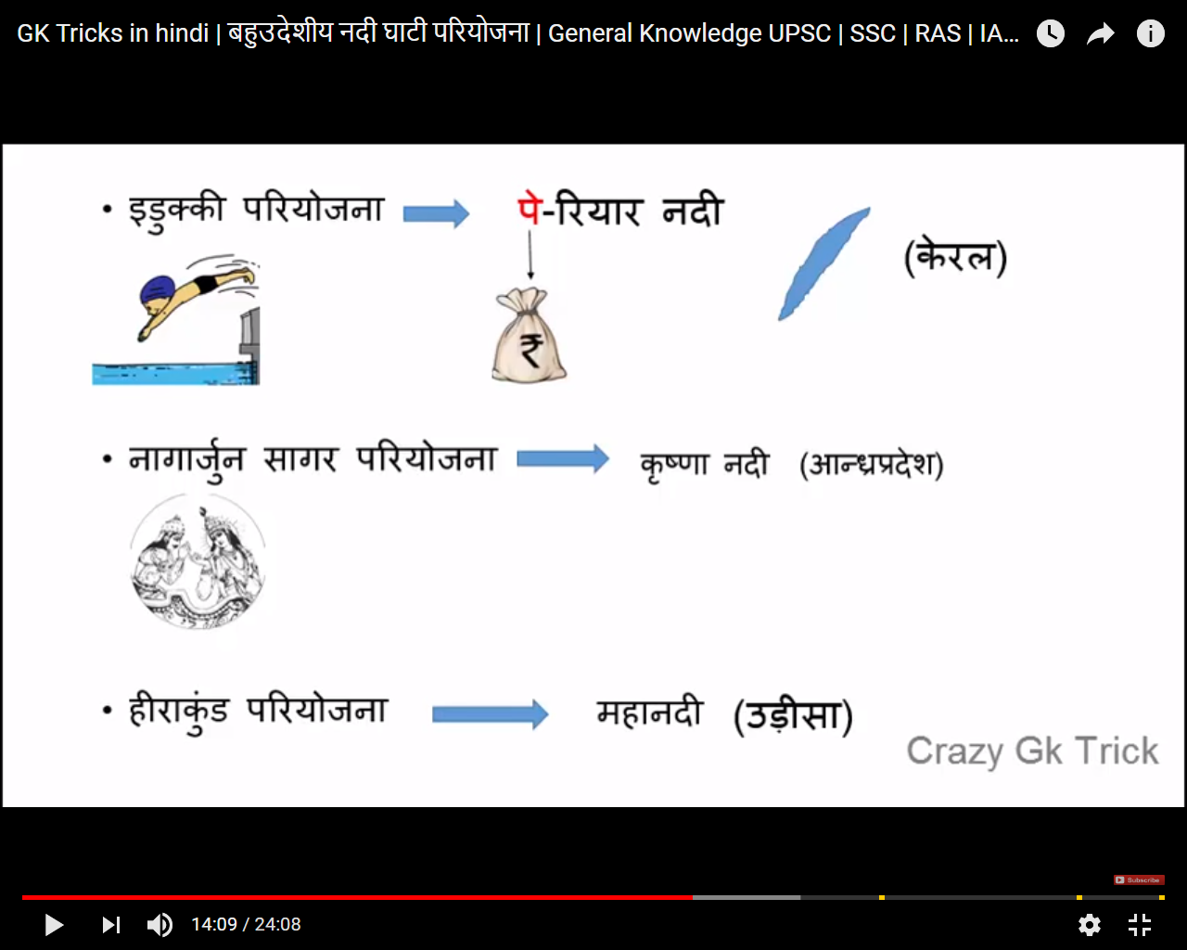

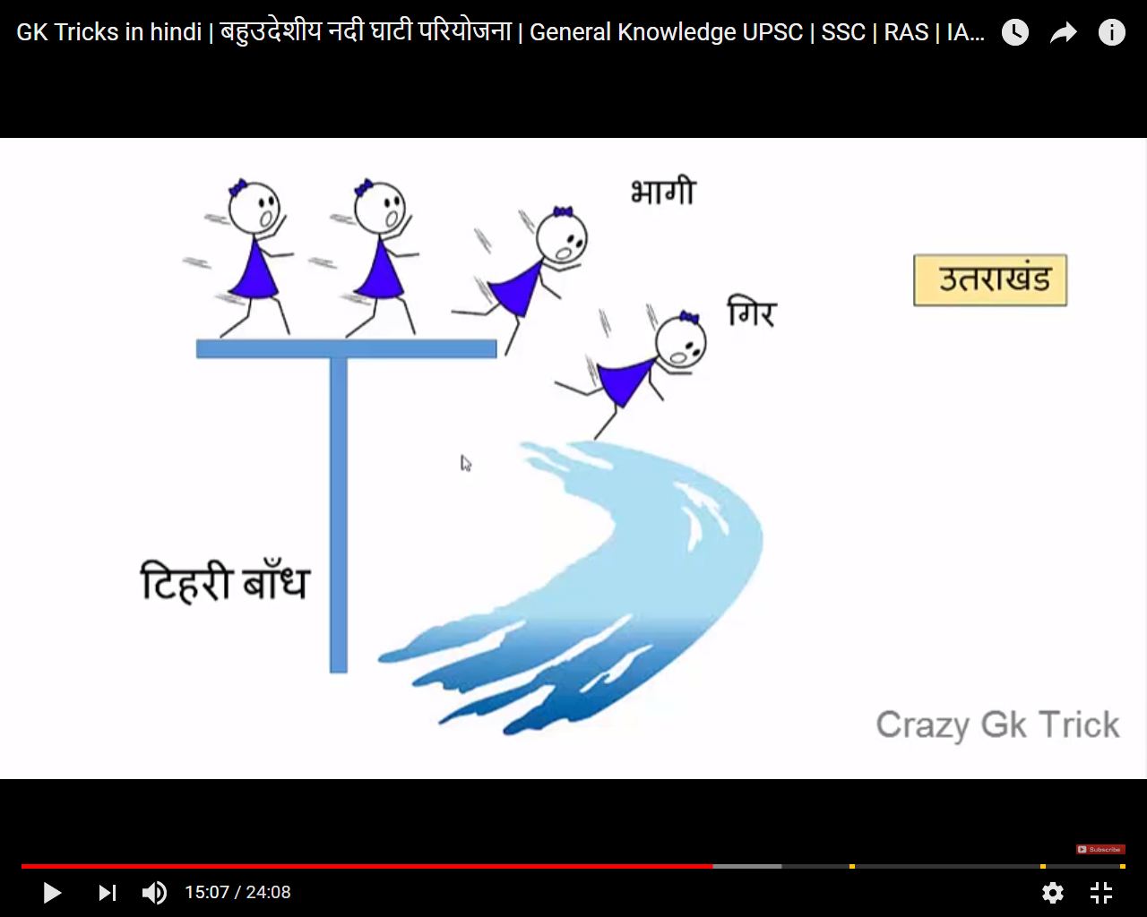

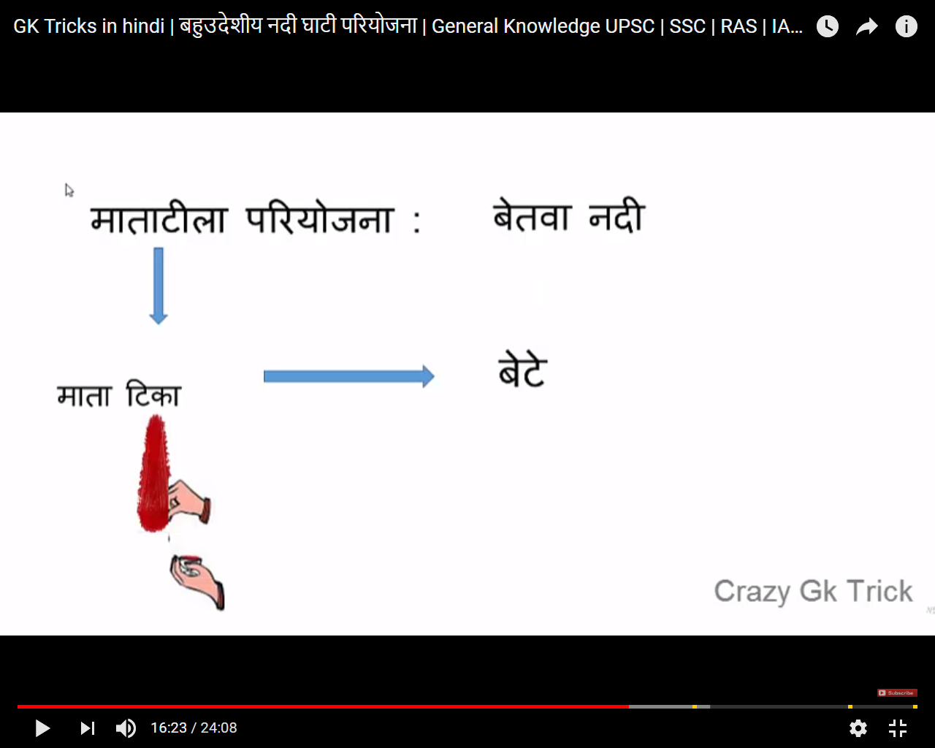

Taking advantage -MP and UP

Raani Laxmi by Dam -Uttar Pradesh

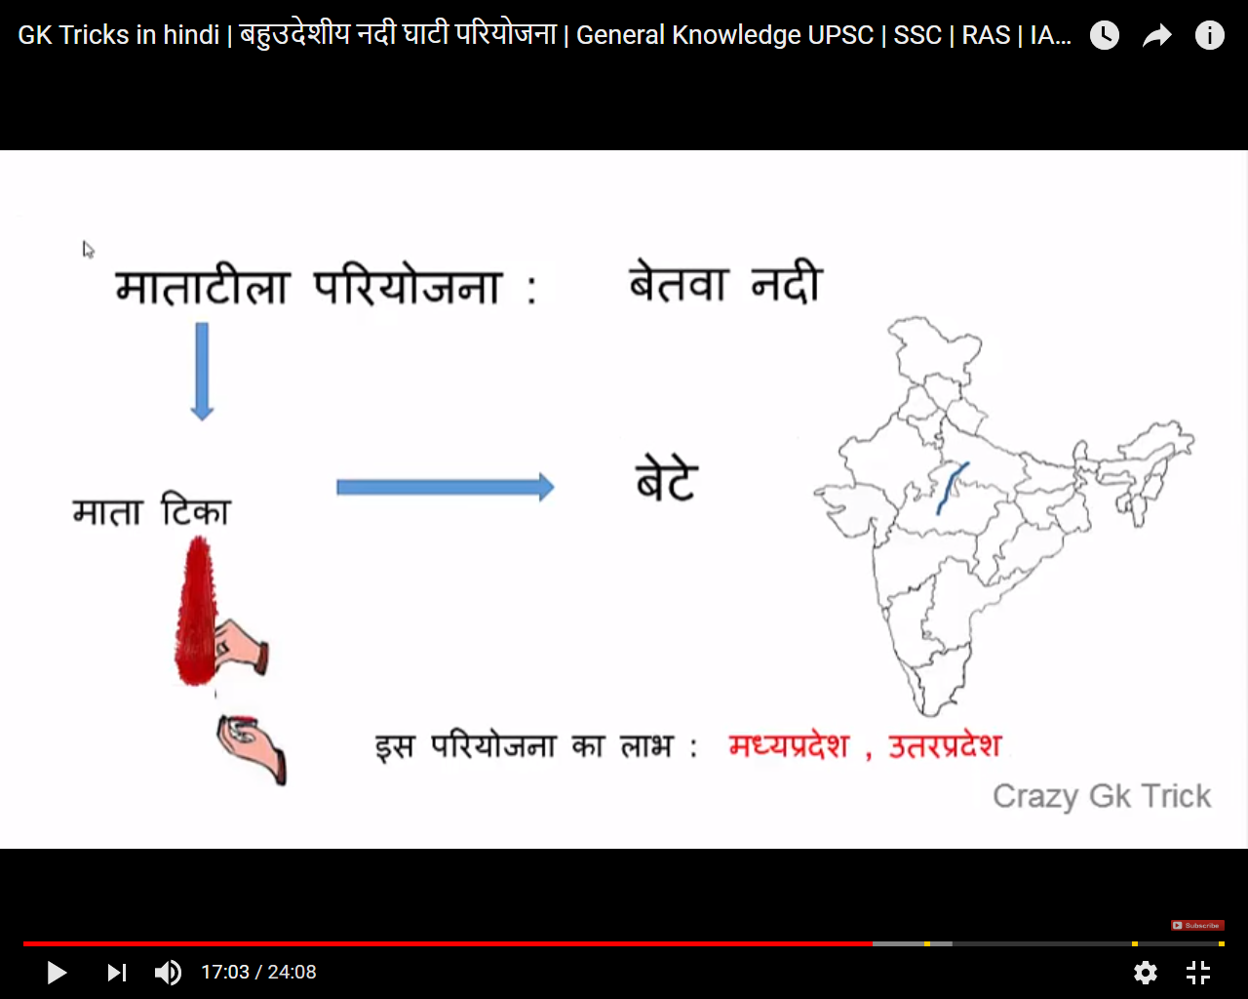

Cambbal Pariyojana

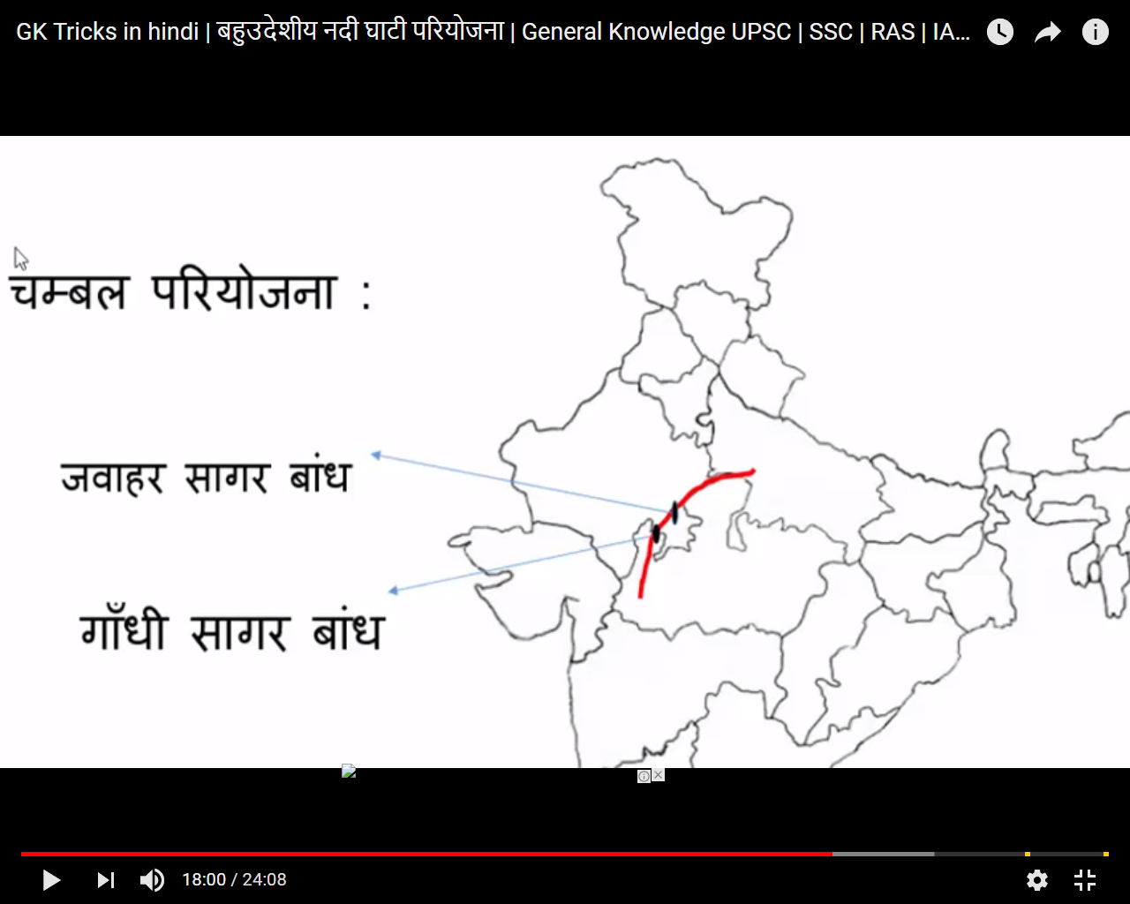

Damodar River Dam-Oldest Pariyojna

Jharkand -West Bengal

